HOW TO INSTALL ITEMS NOT DESIGNED FOR RACKS
SignaLink Panel 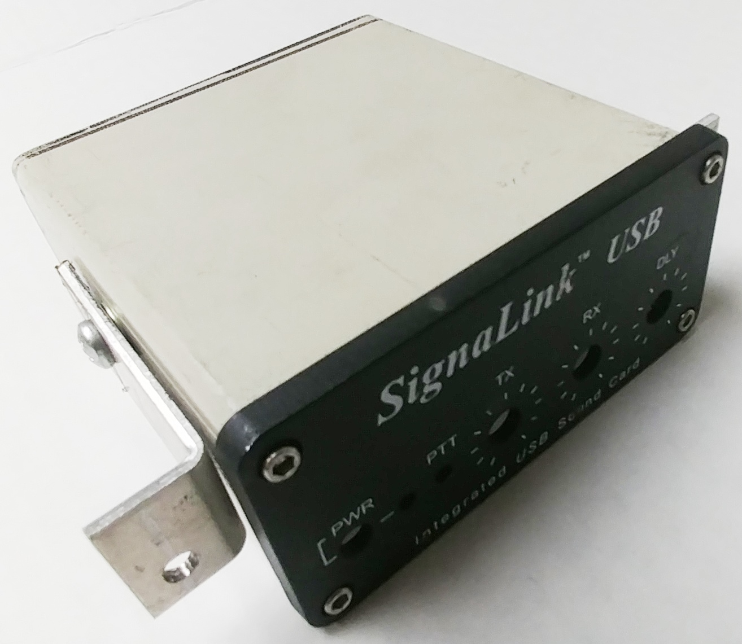 Bracketing Example Shown

The TigerTronics SignaLink is one of many items such as the LDG series of tuners, SGS DR series of modems and more that were never designed to be panel or rack mounted. Novexcomm mounts these items according to the position in the panel based on the design for each customer. Call & email us to help make them work right!

In these cases the housing needs to have threaded inserts installed for bracketing; these are often called rivet-nuts or ‘riv-nuts’. The way they are installed is very easy especially if you have ever used a blind rivet tool (often called a Pop Riveter) and while these are very similar, the tool and inserts are naturally different.

Novexcomm supplies the 90 degree “L” bracket kits to mount them and you will need a Riv-Nut tool to install them. One of the most popular low cost kits is the Harbor Freight Tools Model 1210 which can be found at HarborFreight.com or on most auction websites for around $25 with inserts. Always use the 8/32 sized inserts or larger as their 6/32 size has a very weak tool tip and it breaks off easily. Drill to exactly fit the inserts.

First; remove the cabinet from the device and look inside to determine the best location for drilling to miss the electronics inside. We have done many of these items but certainly not all, CALL with any questions!
For panel-mounted items: install the brackets to the panel & mark the box where the holes are to be drilled.
For tray mounted items: you can bolt them down anywhere they fit; mount the inserts, attach the brackets and then mark & drill the holes in the tray to fit that location. Sometimes our pre-punched holes in the tray line up.

MOUNTING ITEMS THAT HAVE THEIR INSERTS PRE-INSTALLED

Ham & 2-way radios come with their threaded inserts drilled to match the OEM bracket but often those don’t center the radio in the front panel aperture; so you can use our generic 90 degree “L” brackets the same way as above. We can design panels to use the OEM brackets or you may be able to drill them to suit the pattern with the radio centered into the panel aperture so it looks nice OR if you use our generic brackets bolt them to the item first and then set it onto the tray, mark the holes & drill to fit. The results look best when done this way.

NOTE THAT THE HOLES PRE-PUNCHED INTO THE TRAY DON’T LINE UP WITH ANY BRACKET
These are generic stock patterns that allow us to bolt varying equipment to the tray and aren’t designed for any specific bracket or item so don’t be surprised; just drill & bolt the device down and if a hole lines up; great!
Corner brackets 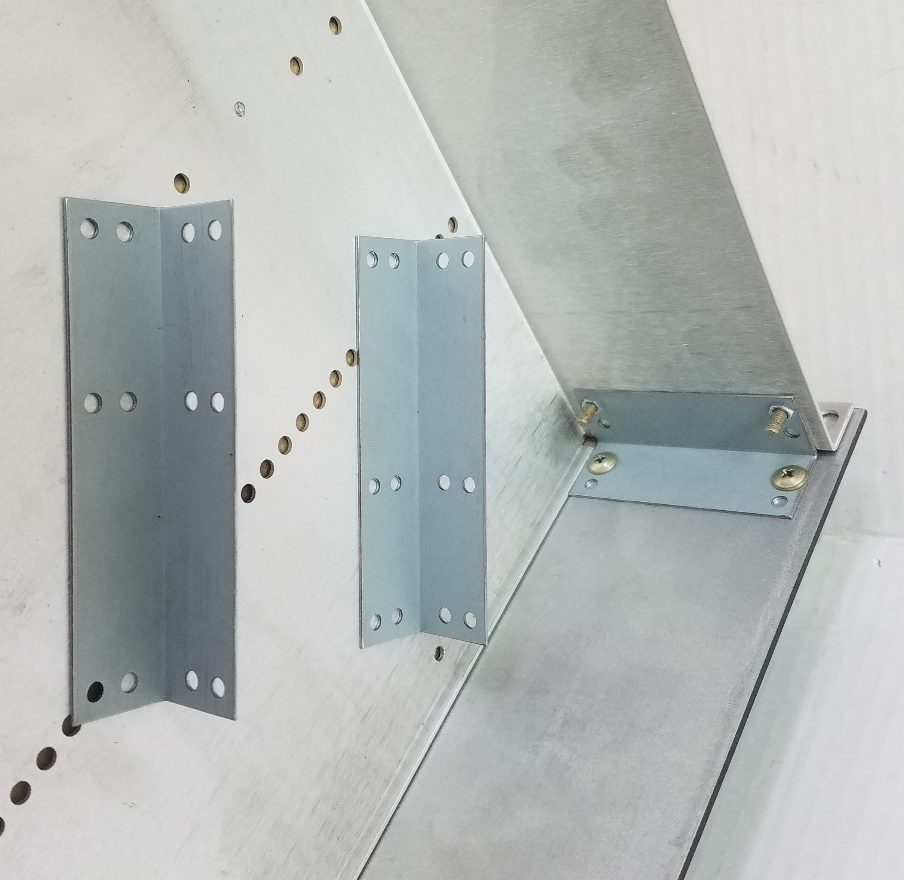 bolt the panel to the tray for special support applications; call if you need them.

